Title

Installation of Ms Office STD 2010

Prepared By

Ankesh Nimavat

Date: 08-Oct-2018

Version 1.0

Document History

Date | Author | Revision | Description
26-10-2010 | Team Lead Helpdesk | 1.0 | Document Creation
08-10-2018 | Team Lead Helpdesk | 2.0 | Company Name changed from TBSS to CBSL

Approved By: | Conneqt Business Solutions Limited
Manager-Technology | 2.0

Distribution List
Name | Department | Company | Rights
Manager-IT Support | Technology | CBSL | Review & Comment
Manager-Technology | Technology | CBSL | Modify
AVP Technology | Technology | CBSL | Review & Approve

Security Classification: CBSLRestricted.

Please find here the Procedure to install Ms Office Std 2010

For All Users:

Step 1 : Select setup file to run the installation setup of MS office 2010

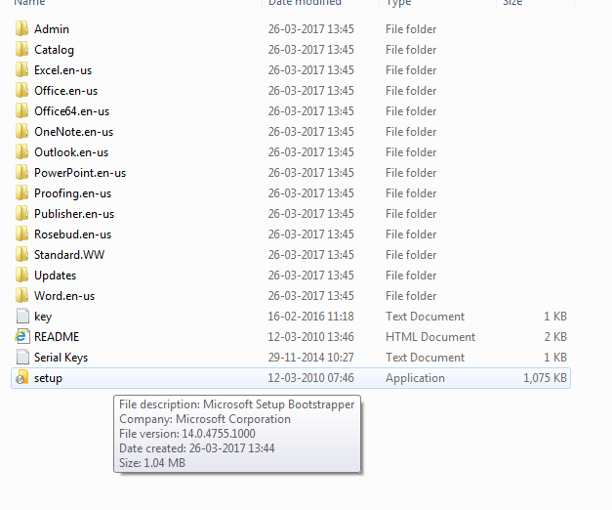

Step 2 : after select setup file as shown above snap below mention pop up will appear check the agreement accept button. Then after press continue as shown below.

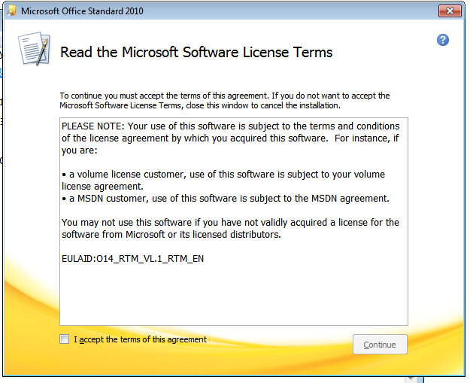

Step 3 : after select the agreement accept button as shown above snap below mention pop up will appear click on Install now button.

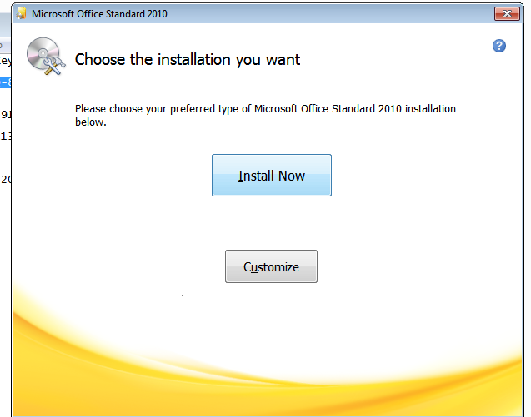

Step 4 : after select Install now button following process will start.

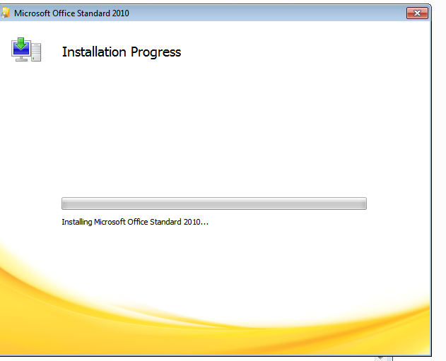.

Step 5 : After completing above mention Process b/m pop up will appear and restart the system.

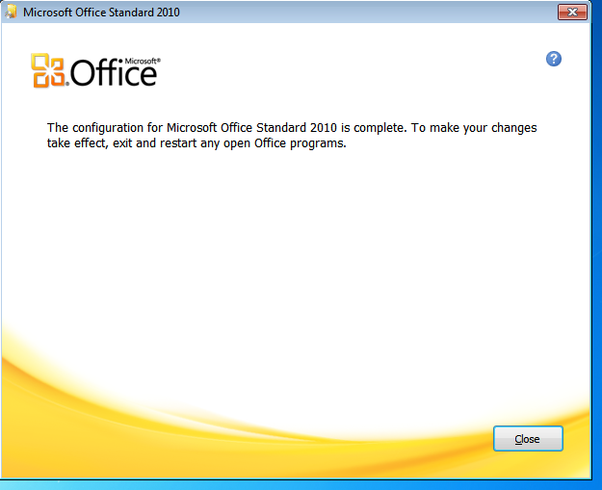

Step 6 : After restarting system go in control panel select program and features and select MS office select change option in task bar as shown in b/m snap.

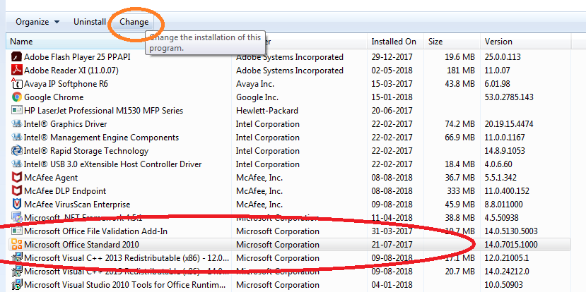

Step 7 : After select change option b/m popup will appear. Activation will done after entering 25 characters. Please find key

6QQ9J-MGH2H-6FF77-PBRKQ-8XPGP

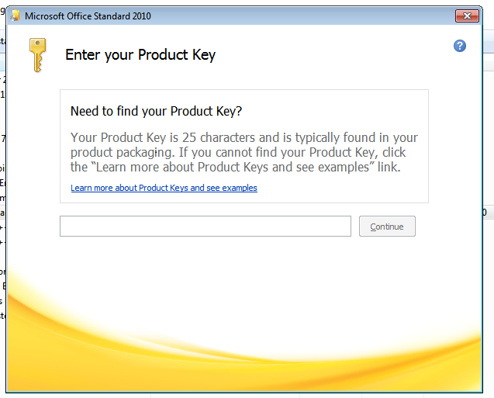

Step 7 : After entering key b/m popup will appear then after press continue button. And MS office activation & installation has been done successfully.

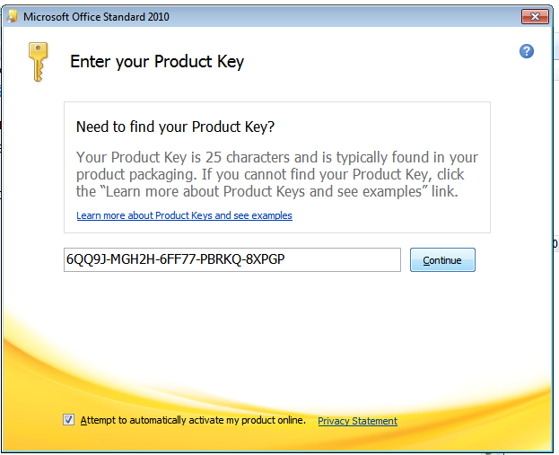

Thank you

